KB Library
  - TMA-Padlock 0.4.0 | User guides and setup information
23 October 2026
Suite reference: the TMApps Master KB Library was not yet published on main at verification. This guide preserves Padlock KB IDs for future registry links.
Keep this guide with your recovery plan. All example accounts and codes in the screenshots are fictional. The same numbered articles are available offline in Settings and can be found with Settings search.

Find a guide
Padlock-KB1 First setup and master password
Padlock-KB2 Add and verify an authenticator
Padlock-KB3 Offline codes, expiry timers and clock problems
Padlock-KB4 Encrypted backup, export and import
Padlock-KB5 Tray and compact authenticator window
Padlock-KB6 Custom icons and account privacy
Padlock-KB7 Appearance, scheduled colours and performance
Padlock-KB8 Locking and security boundaries
Padlock-KB9 Search, support and reporting
Padlock-KB10 Error messages and safe recovery
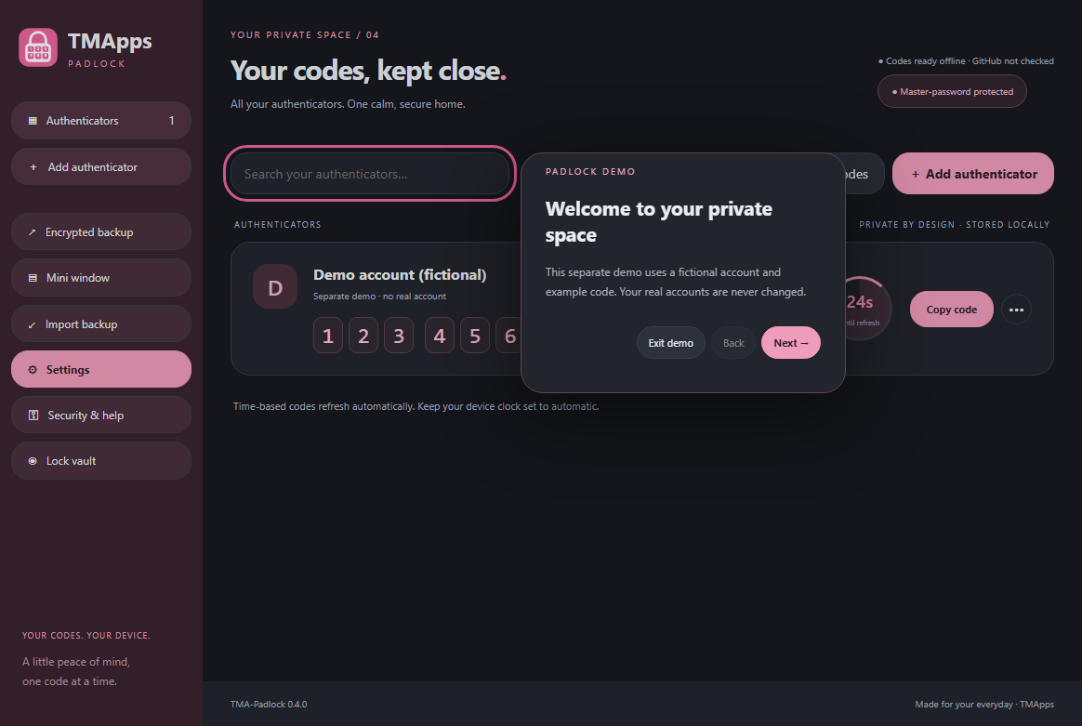
The separate demo introduces the app without changing real accounts.

Padlock-KB1 First setup and master password
Choose Master password for portable encrypted backups. Use a unique password of at least 12 characters and store it safely: there is no reset. Device-key mode depends on your OS account and its secure key store.
Portable backup prompts you to choose a separate backup master password. The first-launch demo is fictional and returns you to setup when closed. Related: Padlock-KB4, Padlock-KB8.
Back to index

Padlock-KB2 Add and verify an authenticator
Choose Add authenticator. Enter a name and the service's Base32 secret or otpauth:// URL. Advanced options support TOTP/HOTP, SHA-1/256/512, 6/8 digits and periods from 15 to 120 seconds.
Select Verify, compare the code with your service and confirm the match. QR image decoding and proprietary Steam/Battle.net enrollment are not supported. Keep the service recovery codes separately. Eye buttons reveal individual password or setup-key fields and reset when locked.
Back to index
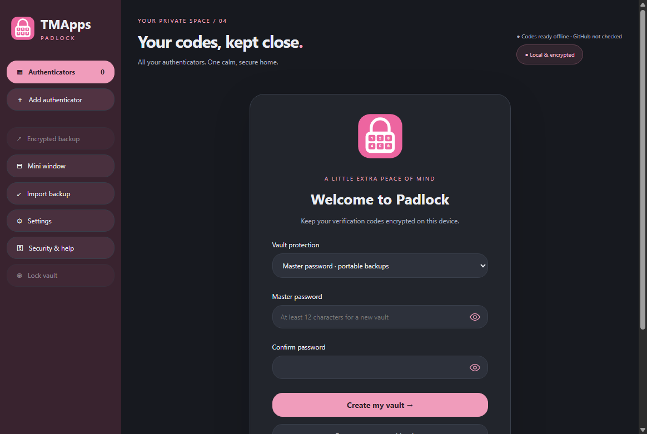
First setup: choose vault protection and enter your master password.

Padlock-KB3 Offline codes, expiry timers and clock problems
Standard TOTP and HOTP codes are generated locally without an internet connection. TOTP uses your device clock; keep automatic date/time enabled and correct clock drift in your operating system. The countdown ring shows remaining validity.
Auto refresh uses the current time, without a network request. If disabled for an account, an expired code becomes dashes until Refresh code is selected. HOTP changes only with Next code; advancing unnecessarily may desynchronize the service. Desktop notifications and help/report links have separate OS/network requirements.
Back to index

Padlock-KB4 Encrypted backup, export and import
Encrypted backup exports a .tmapadlock file from a master-password vault. For a device-key vault, backup prompts you to choose and confirm a separate backup master password. Keep copies in a safe location and retain the backup master password separately. Restore is available before creating a vault and requires that password before installing the file.
Import backup merges into an unlocked vault and requires the source backup password even if your current vault is unlocked. Exact secret/type/algorithm/digits/period matches are skipped; the current account and HOTP counter are retained. Wrong passwords, damaged files and over-limit imports leave the current vault unchanged. Related: Padlock-KB1, Padlock-KB8.
Back to index
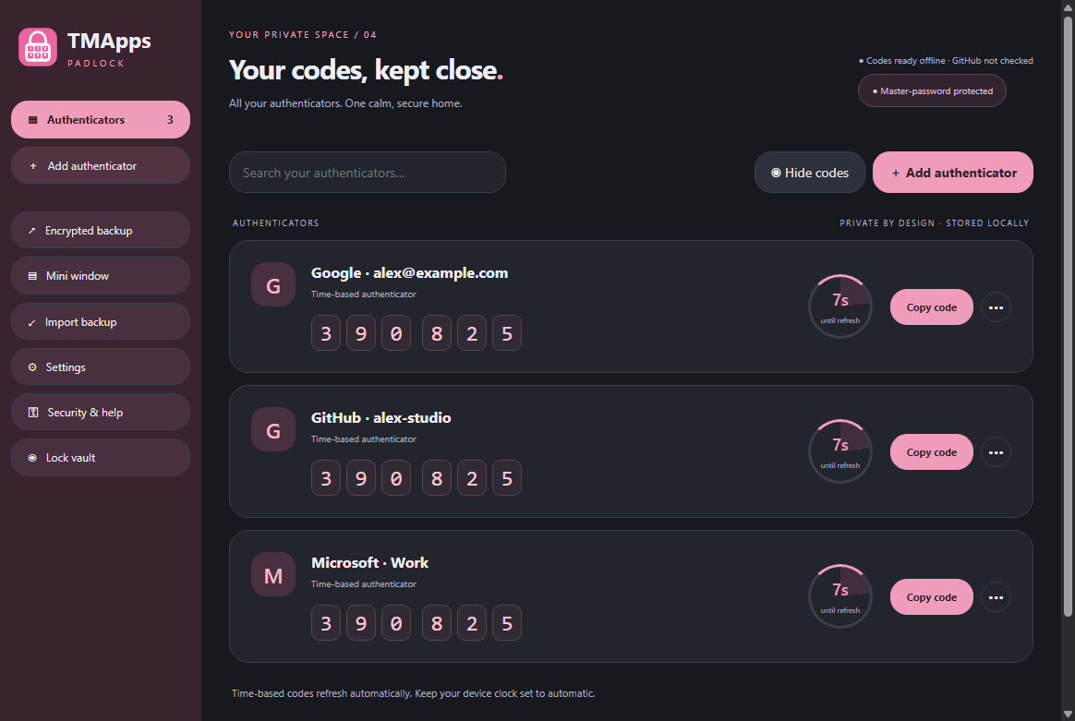
Main authenticator list: expiry rings, code boxes and account menus.

Padlock-KB5 Tray and compact authenticator window
Enable Show tray icon in Settings. The pink bubble tray menu provides Open, Mini authenticator, Settings, Lock and Exit. The mini window is resizable. Right-click an account or select its three-dot menu to copy, refresh, rename, hide, delete or customize its icon.
Mini always on top is in Settings; Open at sign-in is named for the operating system rather than Windows only. Close-to-tray locks the vault. The main and mini windows share one vault and lock together. Linux tray availability depends on the desktop's status notifier support.
Back to index

Padlock-KB6 Custom icons and account privacy
Choose a preset account icon from the account menu or Upload icon for a PNG/JPEG up to 2 MB. Images are decoded and reduced to a 64-pixel PNG; SVG and remote image URLs are not accepted. Icons are stored inside the encrypted vault and travel with backups.
Hide code masks the account across windows and persists after restart. Copy still works for hidden codes. Global Hide codes affects the current window. Clipboard codes clear after 20 seconds if the clipboard still contains the copied value.
Back to index
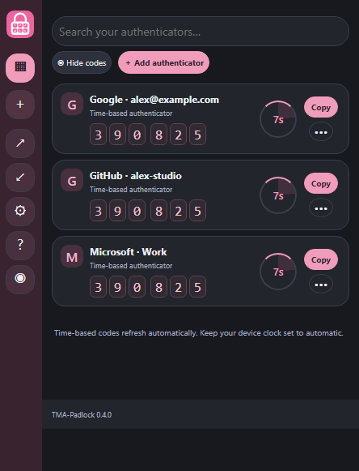 | 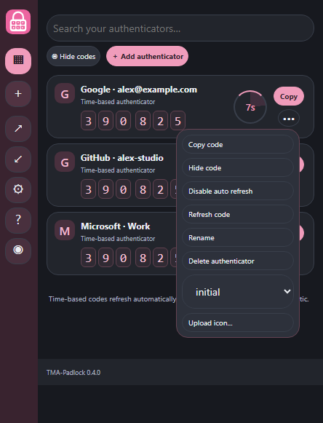
Compact window and right-click account menu, with synthetic accounts.

Padlock-KB7 Appearance, scheduled colours and performance
Choose Pink, Grey or Black in Settings. Enable Scheduled night appearance, set start/end and choose Grey or Black at night. A schedule crossing midnight is supported; equal times mean night appearance all day. Set transition length from 0 to 60 minutes, including 2 or 30 minutes. Initial launch applies the current appearance immediately.
Minimized/hidden or locked windows stop code polling. Close the mini window to reduce memory use. Icons add some memory; notifications run only after enabled backup/import events. Cryptographic password derivation intentionally uses CPU and about 64 MB of working memory while unlocking. Settings descriptions explain these tradeoffs.
Back to index
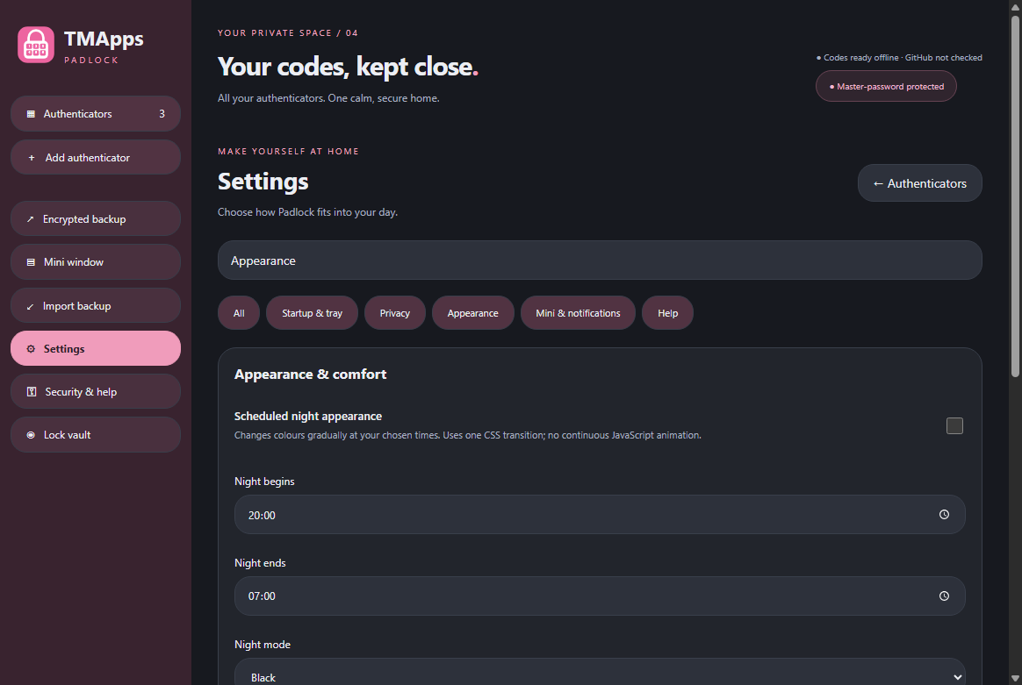
Settings search finds appearance scheduling and transition duration.
For an instant change, set Transition to 0. For a gentler scheduled change, try 2 or 30 minutes. To reduce memory use, close the mini window when it is not needed. The main app remains available through the tray.

Padlock-KB8 Locking and security boundaries
The vault uses scrypt and authenticated AES-256-GCM encryption. Screen lock, suspend, manual lock, inactivity and close-to-tray remove accessible account data and clear copied codes. Use a strong password, protect your OS account and keep recovery codes.
Unlock throttling slows repeated guesses in the app but cannot prevent offline attacks on copied encrypted files. JavaScript strings cannot be guaranteed erased from process memory; malware or an administrator can inspect an unlocked app. Security regression tests and package hardening checks run with every release; this is not a guarantee of absolute security.
Back to index

Padlock-KB9 Search, support and reporting
Settings search matches option labels and KB article text. Disable Include KB articles in settings search to omit articles from keyword results; the library is still available when search is empty. Feature request, Bug report and Issue report open the TMApps GitHub forms. Help opens the online library.
Crash report presents a description, optional sanitized diagnostic and a review checkbox. Upload to GitHub Issues opens a prefilled issue; sign in and select Submit new issue on GitHub to finish. Never paste secrets into reports. Diagnostics contain only app version, OS, architecture, timestamps and allowlisted failure categories; no vault contents, raw errors, stack traces or paths. Offline users can read this library and prepare a report later.
Back to index

Before sending a report
- Review every word in the description. Never include setup keys, master passwords, one-time codes or encrypted vault files.
- The optional diagnostic contains only app/runtime metadata, timestamps and generic failure categories. Raw exception messages and paths are omitted.
- Upload opens a prefilled GitHub issue. Complete sign-in and select Submit new issue on GitHub; nothing is posted automatically.

Online reference
github.com/DaddyTylerXO/TMApps/tree/TMA-Padlock/docs
For the security assessment and performance measurements, see security-assessment.md and performance.md in that folder. Related guides: Padlock-KB3 for offline operation, Padlock-KB4 for recovery and Padlock-KB8 for security boundaries.

Padlock-KB10 Error messages and safe recovery
Could not unlock: check the master password and OS account; do not delete or replace the vault. Too many unlock attempts: wait for the stated cooldown before retrying. Passwords do not match: re-enter both fields using the eye controls if needed. Use a Base32 secret: obtain the manual authenticator setup key from your service; do not paste its login password. Import failed or Backup could not be restored: confirm the source backup master password, file and account limit; the current vault remains unchanged. Vault locked. Try again: unlock and repeat the cancelled operation.
Vault size limit reached: remove unnecessary custom icons or use smaller images; a failed save rolls back the change. EPERM, EACCES or disk errors: ensure the chosen folder is writable, free up disk space and retry after antivirus scanning finishes; do not weaken OS security controls. Desktop notification could not be displayed: allow Padlock notifications in OS settings and check quiet mode. Report is too long: shorten the description or turn off diagnostics, then review again. If an error persists, use Bug report or a reviewed crash report with sanitized text and steps. Suspected vulnerabilities must be reported privately through the GitHub Security tab; never publish real passwords, codes, setup keys or vault files. Codes and KB guides work offline; reports require internet and GitHub sign-in. Related: Padlock-KB4, Padlock-KB8, Padlock-KB9.
Back to index
Keep the original encrypted vault and known-good backups safe while troubleshooting. Never upload a whole application-data folder. When contacting support, include the app version, operating system and architecture, the KB steps you tried and only sanitized error details.

